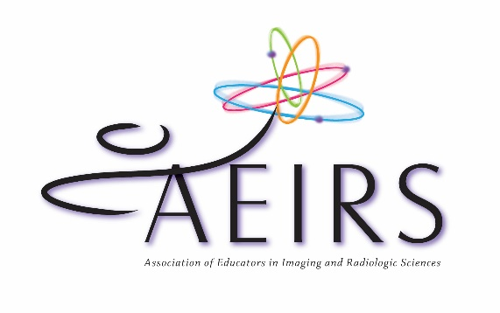

Call for Speaker Presentations
____________________________________

Application to Present – 2021 Annual Meeting

* Primary Presenter - Only the primary presenter is eligible for any compensation.
Name:
Academic Degree/Credentials:
Position/Title:
Institution/Organization:
Address 1:
Address 2:
City:
State:
Zip:
Work Phone:
Fax:
Email:
Are you an AEIRS Member? _____Yes _____No Please note that the Primary Presenter must be an AEIRS member.

NOTE: Contracts will be signed by all presenters. Only the primary presenter is eligible for any speaker compensation. All presenters must be aware that this application is being submitted. Please make a copy of this application for all additional presenters.

Co-Presenter
Name:
Academic Degree/Credentials:
Position/Title:
Institution/Organization:
Address 1:
Address 2:
City:
State:
Zip:
Work Phone:
Fax:
Email:
Are you an AEIRS Member? _____Yes _____No

* Title (10 word limit):

* Session Format:

* Categories which best describe your session:
(You may select as many categories as you wish, but please choose only from among the following categories.)

_____Curriculum Development
_____Program Management
_____Clinical Education
_____Patient Care/Legal/Ethical Issues
_____Imaging & Radiologic Science Innovations
_____Original Research
_____Instructional Technology
_____Creative Pedagogy & Student Learning

* Session Description:
Please supply a 5-6 sentence description of your topic. Please limit your session description to 100 words. Be as specific as possible about the material you will cover in the session. Your description will be used in writing the meeting brochure. Descriptions that are too short or vague will be returned.

* Session Outline:
Please supply your presentation outline. Applications without an outline included will be returned.

* Learning Objectives of Session:
List the three things that the participants will be able to do at the end of the session. These learning objectives should take the form of “You will learn to…” followed by at least 3 bulleted items that attendees will learn. Sessions submitted without learning objectives will not be considered.

* Please include a Speaker Biography (no more than two paragraphs):

* Have you presented this topic at another conference? If yes, please specify the date and association for which it was presented.

* Available Dates:
_____July 8, 2021 – Jacksonville, Florida
_____July 9, 2021 – Jacksonville, Florida

Application Deadline:
Submissions must be received by June 15, 2020.
This date must be firm to allow the board time to discuss applications.

Send this completed application electronically to tammy.webster@unmc.edu. Applications need to be submitted electronically to be considered.

Acceptance:
Notice of Acceptance will be emailed in August. A high resolution photo, preferably a headshot, will be requested at the time of your acceptance. A digital image of 1MB or greater will print the best in the brochure. Your CV will be requested at the time of acceptance if you are not ARRT registered. A Confirmation of Presentation contract will be sent in January and will need to be returned by February 1st. Handouts will need to be sent to the Executive Office by June 15th.
Primary Speaker Compensation Package Selection—Select One Option:
_____Option 1: Members, non-members, vendors and consultants speaking on a topic NOT directly related to their business. Compensation is comprised of: Primary presenter compensation to include conference registration for the entire two-day AEIRS meeting at no charge.
_____Option 2: In-Kind Sponsor: Any employee of a vendor or individuals who are consultants, regardless of AEIRS membership status, who are speaking on a topic directly related to their business are recognized through in-kind sponsorship. The only compensation provided is complementary conference registration for each day speaking.
Questions? Please email tammy.webster@unmc.edu or call 402-559-3846.

THE FINE PRINT
- Be inclusive of educators in all imaging and radiologic sciences in your presentation.
- If your presentation is accepted, we will do our best to schedule you during your preferred dates; however, a specific date and time cannot be guaranteed.

